# Setting up Application Environment Install IBM Cloud CLI

**Step 1.** Navigate to cloud.ibm.com

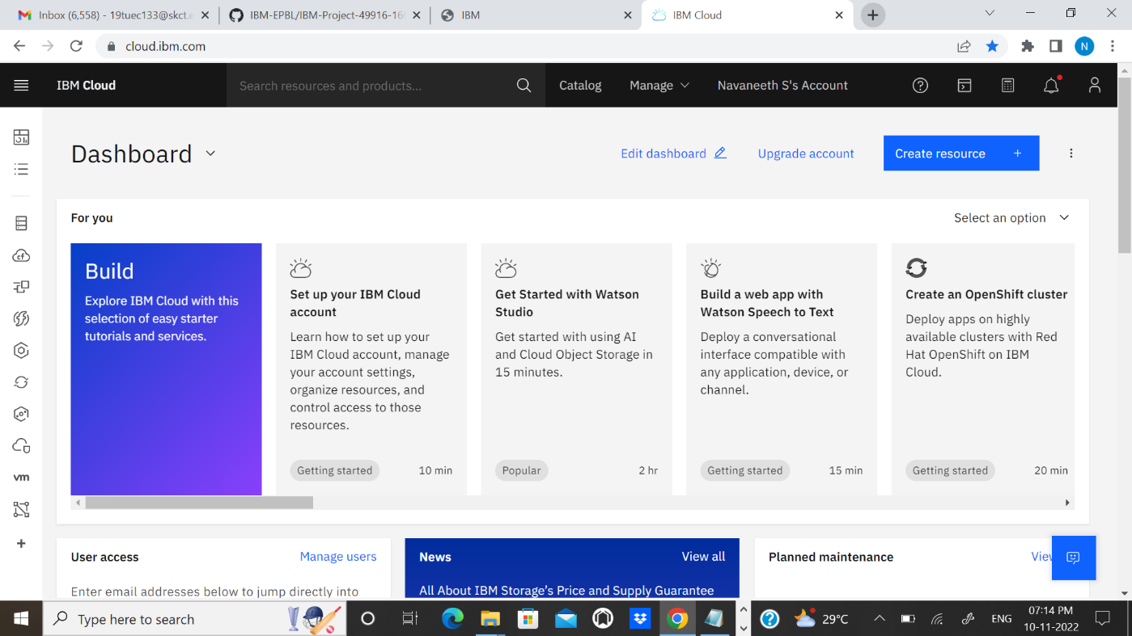

**Step 2**. Search on Container Registry and give get started and follow the steps to install IBM Cloud CLI

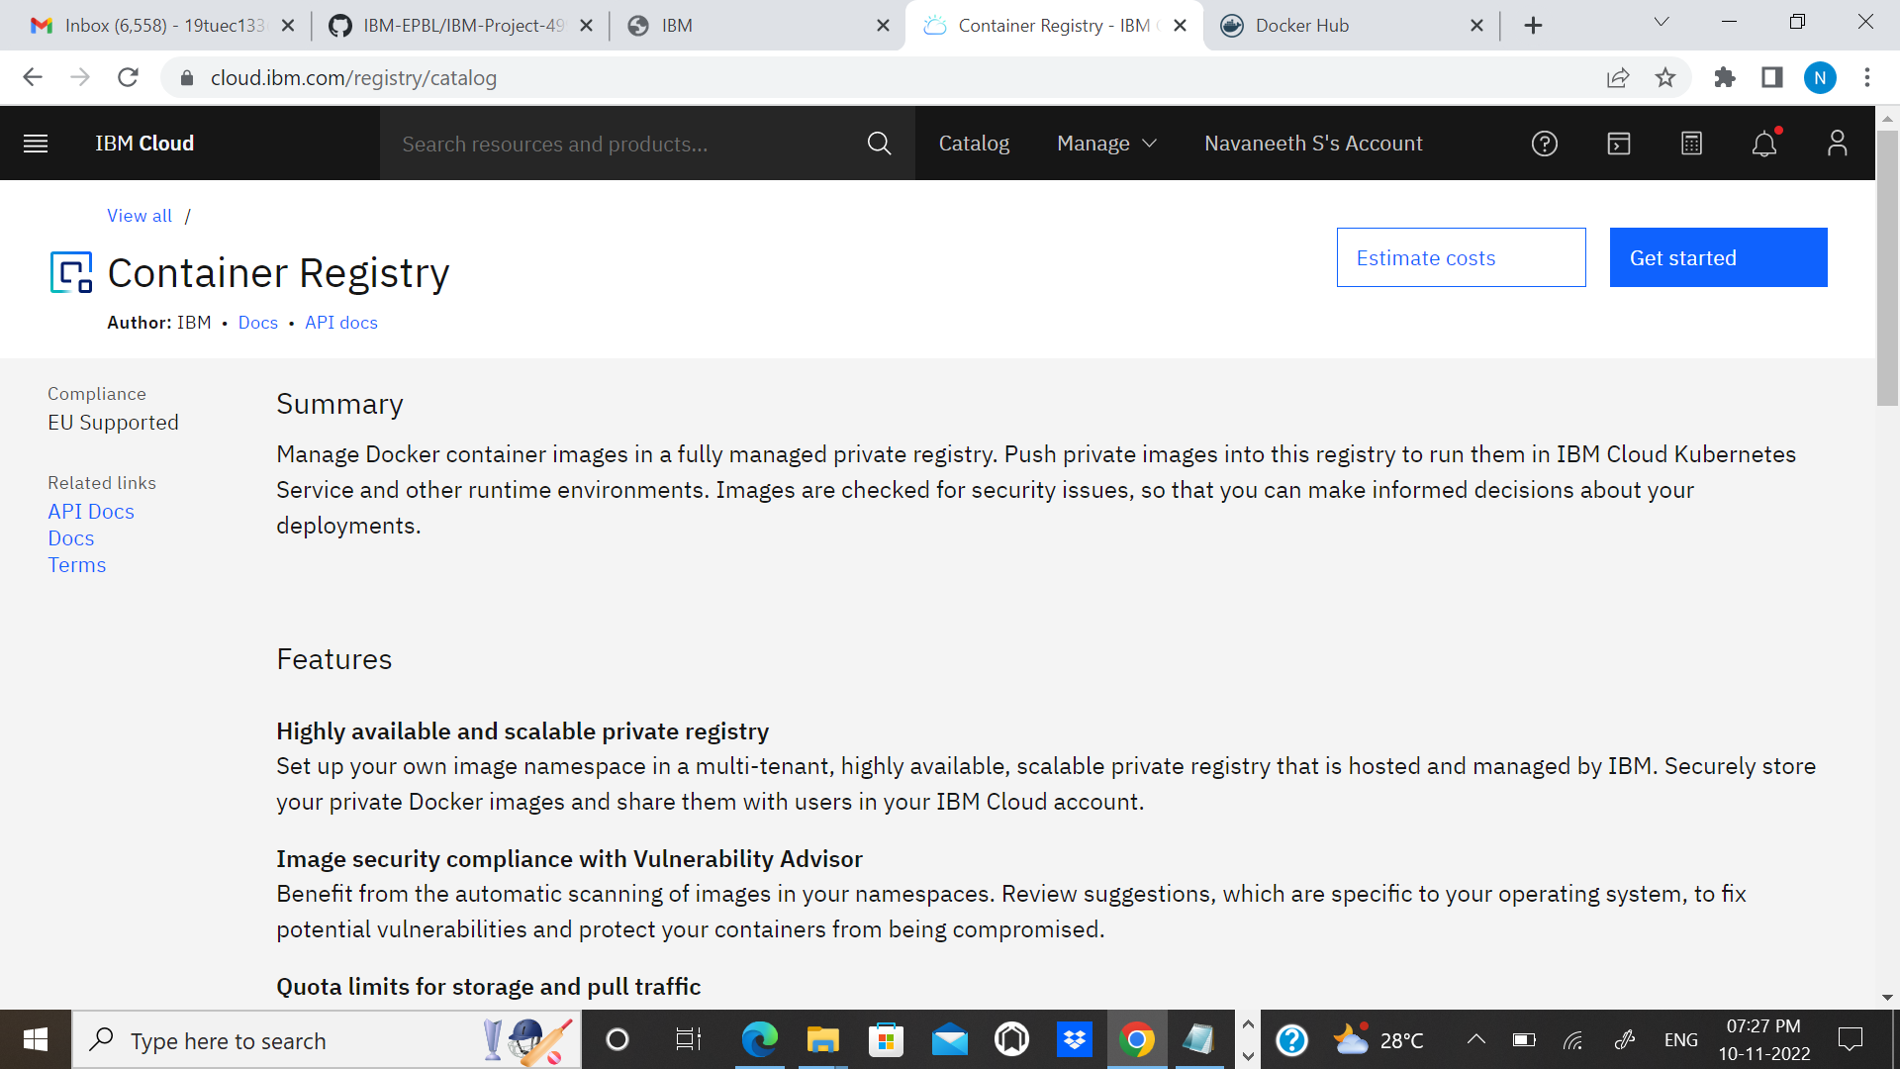

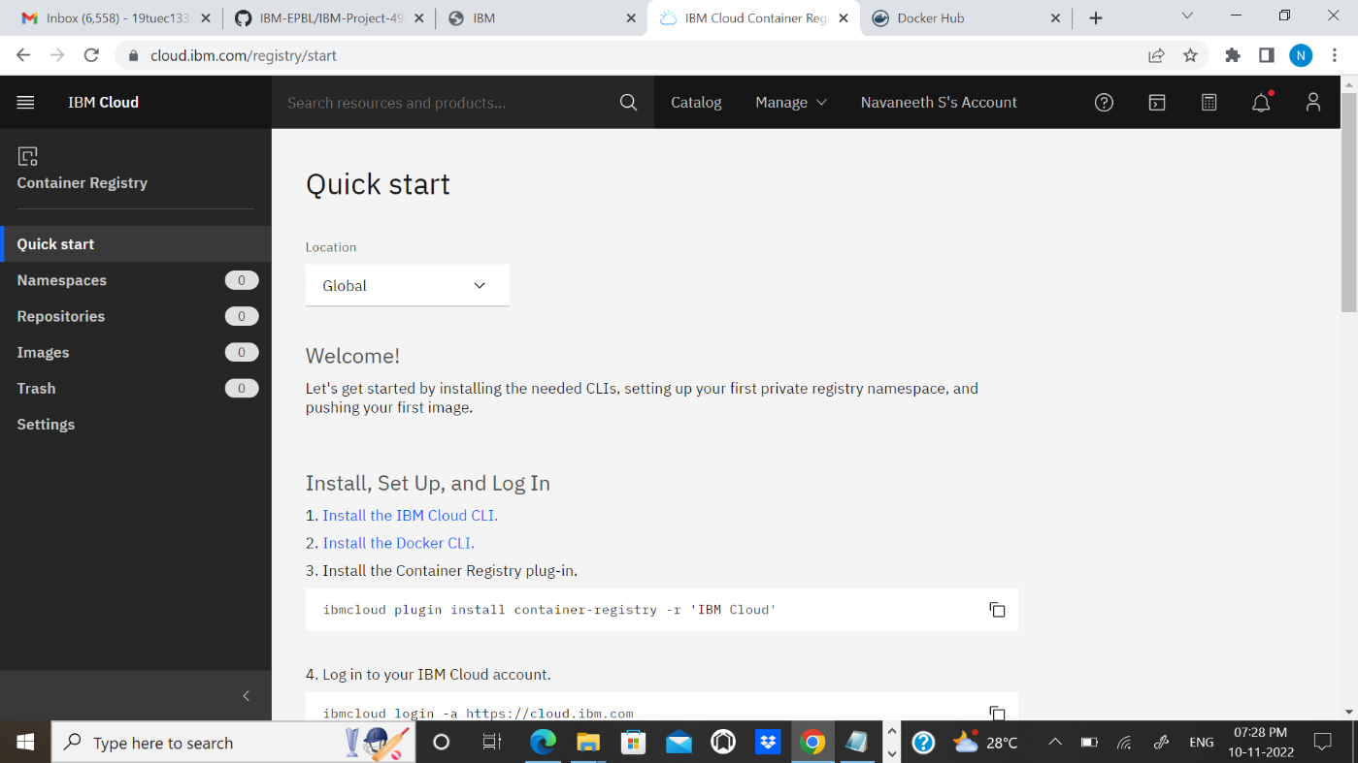

**Step 3**.Download windows 64 bit installer

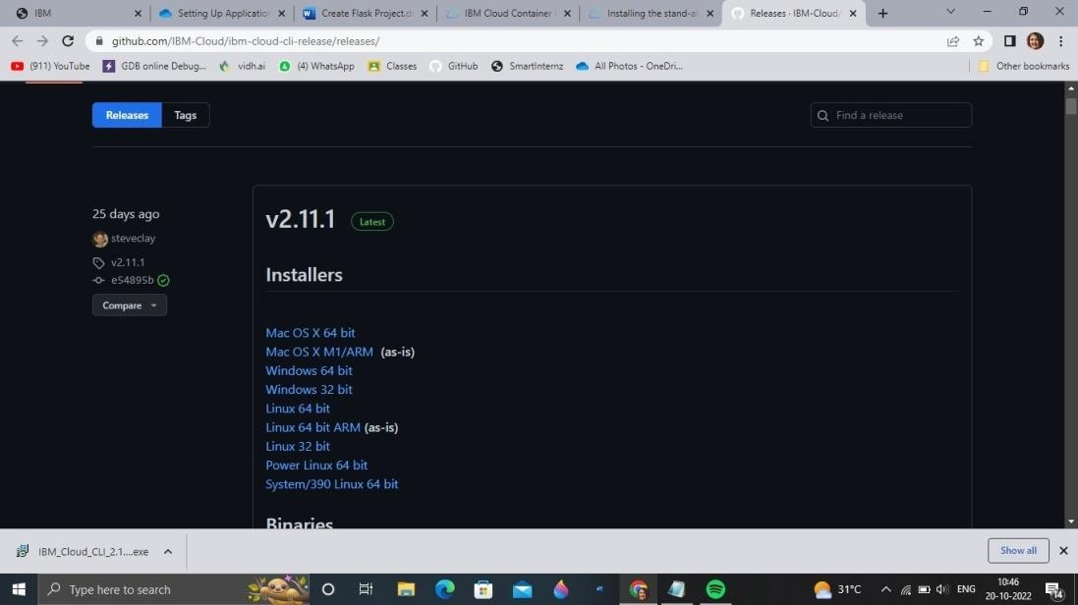

**Step 4.** Open the downloaded .exe file and run it to install IBM Cloud CLI

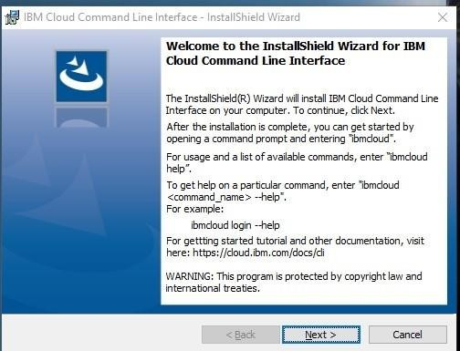

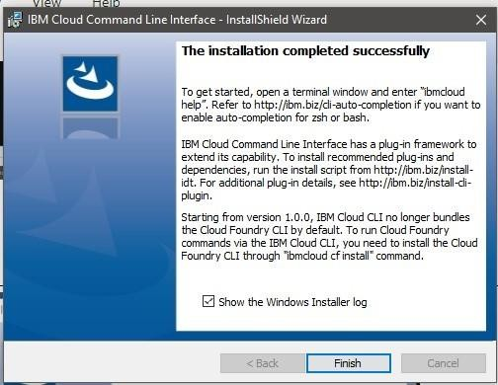

# OUTPUT:

IBM Cloud CLI is installed successfully